Applied Programming Concepts: Assignment 5

Naomi Torre Cardenas

In assignment 5 the functions created in the previous assignment were to be coded. The program written also will take the diagrams and models created in the previous assignment and turn it into code. First as a group a CURSE database was created with values. Then when writing the program, the functions were split up between Sterling, Chandler and I. Sterling worked on the menus, and add/remove from system. Chandler worked on the assemble/print roster and adding/removing course from semester schedule. While I worked on login/logout, searching all courses and searching with parameters. Once the functions were done, they were put into a base and derived classes and bugs were fixed as a group. Then a TestMain.py was created to test everything put together in the classes.

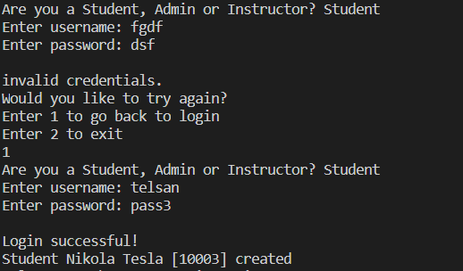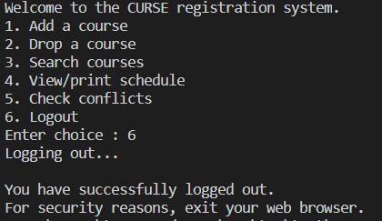

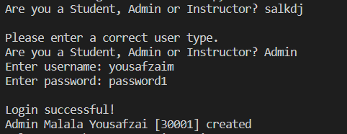

Figure 3: Admin user logging in

Figure 1: Student user logging in

Figure 2: Student user logging out

In figure 1 a student user is on the login page and enters the wrong username and password. This results in an error message that says invalid credentials. The student then enters 1 to try again and this time enters the correct credentials. This results in a message that says login successful. These results were the expected outputs proving that the login function works correctly and checks that the user’s credentials are correct.

In figure 2 the student user is logged in and brought to the student menu. On the student menu the user can see all the different functions they can perform. The user then enters 6 which is to logout and is successfully logged out. A message letting the user know they’ve logged out appears. In the login function once the user enters the correct credentials, they are brought to a menu that corresponds to their user type which is what is seen in figure 2. Having these outcomes proves that the login and logout functions work properly.

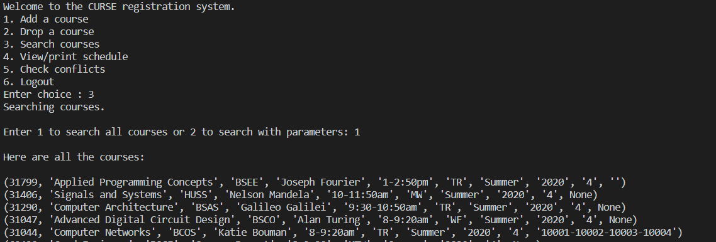In figure 3 a different user tries to log in. First the user enters an incorrect user type and is told through a message to enter a correct user type. The user then enters Admin, along with the correct credentials and is successfully logged in. This output once again proves that the login function works as it should for multiple user types.

Figure 4: User chooses to search all courses

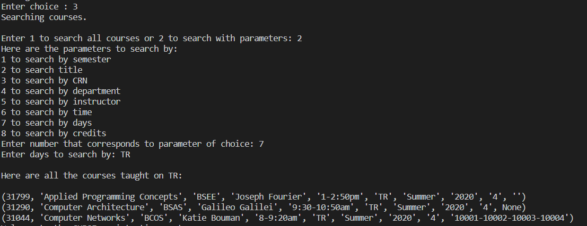In figure 4 the student user choices option 3 which gives the user the option to either search for all courses or search courses with parameters. The user choices to search all courses and all the courses in the CURSE database are displayed. This proves that the search courses and search all courses function works properly because it is what was expected.

Figure 5: User searches courses with the parameter being the day

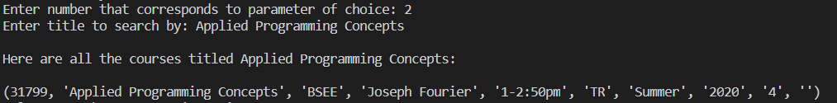

Figure 6: User searches courses with the parameter being the title

In figure 5 and 6 the user chose to search courses with parameters. The first time was searching courses with the parameter being courses that are taught on TR. When the user entered the parameter 3 courses were displayed which was what was expected. The second time was searching courses with the parameter being searching for courses titled Applied Programming Concepts. When this was done only one courses was displayed. These results were the correct outputs proving that the search course and search course with parameters functions work as they should.

Link to Github: <https://github.com/stpilks99/APC-Assignment-5>